Name_______________________________________________________Date______________

Chapter 5 (Part 2) Test Review Honors Algebra 2

***Part 1: Multiple Choice***

1) Which expression is equal to ?

A  C 

B  D 

2) Which is equal to an integer?

F  H 

G  J 

3) Which is an extraneous solution to?

A  B 

C and  are both extraneous solutions. D. There is no extraneous solution.

4) What is the solution set to the equation ?

F ∅ H {1.5}

G {0} J {0, 1.5}

5) Which could be the equation for the graph?

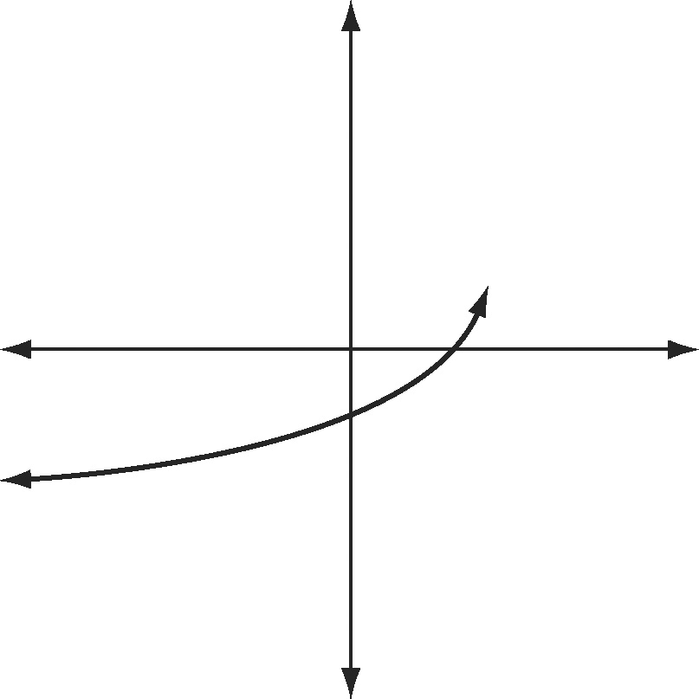

A 

B 

C 

D 

***Part 2: Open-ended***

***Simplify each expression. Assume that all variables are positive.***

6) 7)

8) 9)

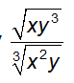10) 11)



12)

***Write each expression by using rational exponents. Assume that all variables are positive.***

13) 14)

15) 16)

***Simplify each expression and write it by using a radical. Assume that all variables are positive.***

17) 18)

19) 20)

***Explain whether each statement is sometimes, always, or never true for nonzero values of the variables.***

21) 22)

***Using the graph of $f\left(x\right)=\sqrt{x}$ as a guide, describe the transformation and graph each function. Then, state the domain and range.***

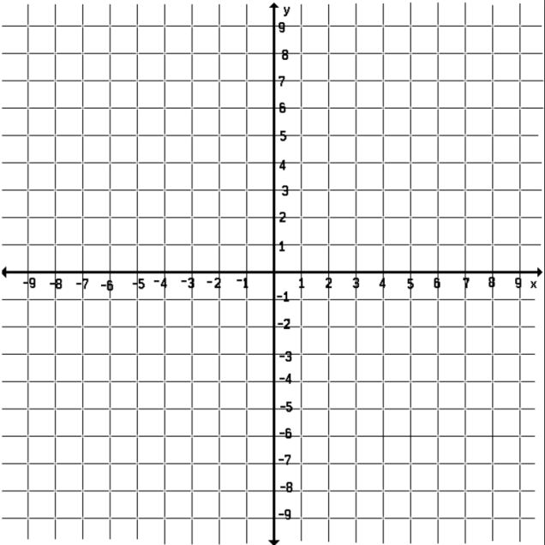23) $-4\sqrt{x}+1$

24) $3\sqrt{-x}+2$

25) $\frac{1}{3}\sqrt{-(x+2)}$

***Use the description to write the square-root function g.***

26) If is transformed by translating it 3 units to the up, then stretching it vertically by a factor of 2, and then finally reflecting it over the *y*-axis, what will the resulting function be?

27) If  is transformed by translating it 2 units to the right, then stretching it horizontally by a factor of 2, and then finally reflecting it over the *y*-axis, what will the resulting   
function be?

***Solve each equation.***

28) 29)



30) 31)

32) 33)

***Part 3: Word Problems***

34) The cube root of the square root of a real number *n* is 16.What is the value of *n?*

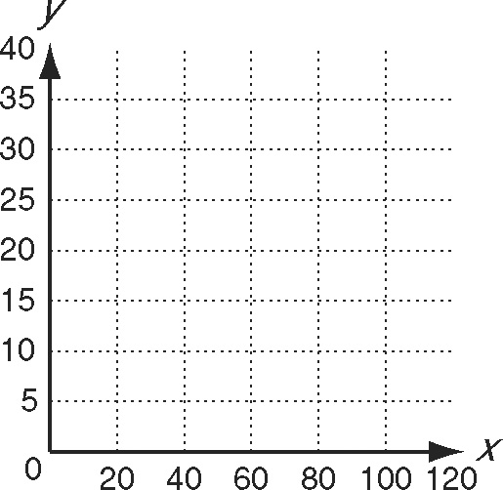35) **On Earth the distance, *d*, in kilometers, that one can see to the horizon is a function of altitude, *a,* in meters, and can be found using the function $d\left(a\right)=3.56\sqrt{a}$*.* To find the corresponding distance to the horizon on Mars, the function must be stretched horizontally by a factor of about $\frac{9}{5}$**

a. Write the function that corresponds to the

given transformation.

b.Use a graphing calculator to graph the function and

the parent function. Sketch both curves on the coordinate plane.

c.Use your graph to determine the approximate distance to the horizon from an altitude of 100 meters:

on Earth ______________________

on Mars ______________________

36) **The formula $s=\sqrt{30fd}$**  **can be used to estimate the speed, *s,* in miles per hour that a car is traveling when it goes into a skid, where *f* is the coefficient of friction and *d* is the length of the skid marks in feet.**

Kody skids to a stop on a street with a speed limit of 35 mi/h. His skid marks measure 52 ft, and the coefficient of friction is 0.7. Kody says that he was driving only about 30 mi/h. Kody wants to prove that he was not speeding.

a. Solve the equation for *d* in terms of *s*.

b. How long would the skid marks be if he had been driving at a speed of 35 mi/h?

c. Was Kody speeding or not? Explain how you know.

d. Find his actual speed.

37) Rafael made a ceramic cube in art class. The cube has a volume of 336 cm3. What is the side length of the cube to the nearest centimeter?