Name__________________________________________________________ Date__________
Honors Algebra 2 Graphing Quadratics

Solving Quadratics
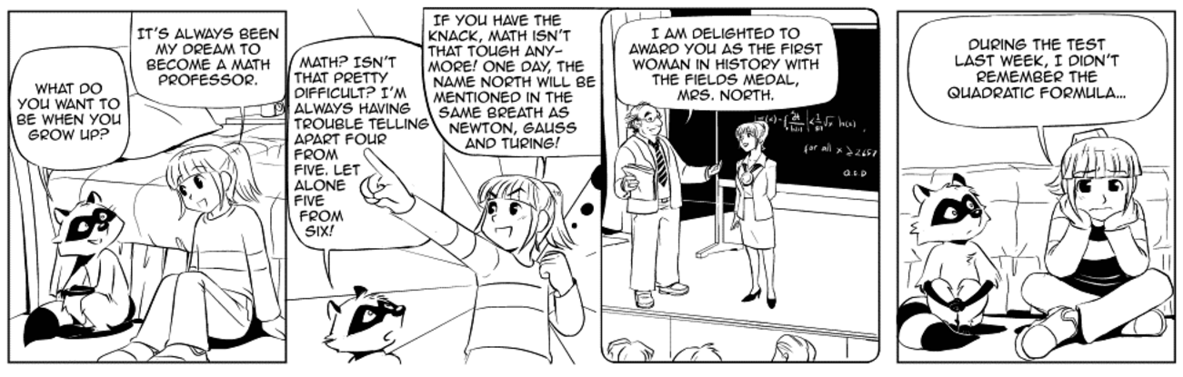

Just when you thought it was over… more quadratics! We have described, analyzed, graphed and created quadratic equations. Now, it is time to solve!

Each of you has been assigned to a group listed below. Within your group, you will watch the listed video(s). You will be expected to take notes, complete examples, and be an expert on your topic. After you have watched the videos and have taken notes, complete the provided problems in your packet. Then, you and your group will present your topic to a new group. You will act as the teacher to instruct your fellow classmates.

Get ready to become the teacher!

Solving by Graphing:
https://www.youtube.com/watch?v=saXEJW1Y1Oo
https://www.youtube.com/watch?v=LplAWEWuWTU
Vocab Words to know:
Zero of a function
X-intercept

Notes on how to solve a quadratic equation by graphing: (This should include examples.)
What are we looking for on the graph to determine the x-intercepts or solutions to the quadratic equation?

What is the first piece of information you need to find when graphing a quadratic? Find it for the given example.

Then, what should we plot on our graph? Find it for the given example.

What is the final point that needs to be plotted in order to graph the quadratic equation? Find it for the given example.

Although it is not shown on the video, complete the table for the quadratic equation shown in the example. Notice that the vertex is in the center of the table.
x |  |  | 2
y |  |  | 0

Graph the quadratic equations and determine the solution(s).

Example 2 (on video)
Equation:___________________________
Vertex_____________________________
Y-intercept_________________________
x
y
(Be sure the vertex is in the center of the table.)
Solution(s)___________________________

Example 3)
Equation:___________________________
Vertex_____________________________
Y-intercept_________________________
x
y
(Be sure the vertex is in the center of the table.)
Solution(s)___________________________

Solving by Graphing (Using the Calculator) (2nd video listed):
What are the steps to solving a quadratic equation using the calculator?

What is the solution(s) to Example 1?

What is the solution(s) to Example 2?

What is the solution(s) to Example 3?

Name__________________________________________________________ Date__________
Honors Algebra 2 Graphing Quadratics

Solving Quadratics

Just when you thought it was over… more quadratics! We have described, analyzed, graphed and created quadratic equations. Now, it is time to solve!

Each of you has been assigned to a group listed below. Within your group, you will watch the listed video(s). You will be expected to take notes, complete examples, and be an expert on your topic. After you have watched the videos and have taken notes, complete the provided problems in your packet. Then, you and your group will present your topic to a new group. You will act as the teacher to instruct your fellow classmates.

Get ready to become the teacher!

Solving by Factoring:
https://www.khanacademy.org/math/algebra-home/alg-quadratics/alg-solving-quadratic-equations-by-factoring/v/example-1-solving-a-quadratic-equation-by-factoring
https://www.khanacademy.org/math/algebra-home/alg-quadratics/alg-solving-quadratic-equations-by-factoring/v/solving-quadratics-by-dividing-and-factoring
https://www.khanacademy.org/math/algebra/quadratics/quadratics-square-root/v/solving-quadratics-by-taking-square-roots
Vocab to know: Roots of a Function
Notes on how to solve a quadratic equation by factoring: (This should include examples.)
What number must your equation be set equal to in order to solve by factoring?

What method of factoring was used in the video example? Are there other methods of factoring? Show the example in the video.

What do we do with each factor once we have successfully factored each expression? Show the example in the video.

What should we try to do if we have a leading coefficient that is not 1?

Show the factoring of the example from the second video.

Explain, in your own words, how to solve quadratic functions using square roots. Show this using the example in the third video.

Complete the 2nd example in the third video below.

Name__________________________________________________________ Date__________
Honors Algebra 2 Graphing Quadratics

Solving Quadratics

Just when you thought it was over… more quadratics! We have described, analyzed, graphed and created quadratic equations. Now, it is time to solve!

Each of you has been assigned to a group listed below. Within your group, you will watch the listed video(s). You will be expected to take notes, complete examples, and be an expert on your topic. After you have watched the videos and have taken notes, complete the provided problems in your packet. Then, you and your group will present your topic to a new group. You will act as the teacher to instruct your fellow classmates.

Get ready to become the teacher!
Solving Using the Quadratic Formula:
https://www.khanacademy.org/math/algebra-home/alg-quadratics/alg-solving-quadratics-using-the-quadratic-formula/v/using-the-quadratic-formula
https://www.khanacademy.org/math/algebra-home/alg-quadratics/alg-solving-quadratics-using-the-quadratic-formula/v/quadratic-formula-3

Vocab to know:
Discriminant

Notes on how to solve a quadratic equation using the quadratic formula: (This should include examples.)
What is the quadratic formula?

Where do we get a, b, and c from to use in the formula?

What must a quadratic equation be equal to in order to use the quadratic formula?

Complete two of the examples in the video below.

What is the discriminant?

Using the discriminant, when will a quadratic equation have 2 real solutions?

Using the discriminant, when will a quadratic equation have 1 real solution?

Using the discriminant, when will a quadratic equation have 2 imaginary solutions?

What will the graph of the quadratic equation look like with 2 real solutions?

What will the graph of the quadratic equation look like with 1 real solution?

What will the graph of the quadratic equation look like with 2 imaginary solutions?

Complete 2 examples from the second video.

Solving Quadratic Equations
Find the zeros of each function by graphing and using a table.
1) $f\left(x\right)=-x^{2}+4x-3$

2) $g\left(x\right)=x^{2}+x-6$

3) $f\left(x\right)=x^{2}-9$

Find the zeros of the functions using a graphing calculator.
4) $f\left(x\right)=x^{2}+2x-8$ 5) $g\left(x\right)=x^{2}-16$ 6) $h\left(x\right)=x^{2}-x-12$

7) $f\left(x\right)=-2x^{2}+4x$ 8) $g\left(x\right)=x^{2}-5x-6$ 9) $h\left(x\right)=3x^{2}+x-4$

10) A baseball player hits a ball toward the outfield. The height h of the ball in feet is modeled by $h\left(t\right)=-16t^{2}+22t+3$, where t is the time in seconds. In addition, the function $d\left(t\right)=85t$ models the horizontal distance traveled by the ball.

a) If no one catches the ball, how long will it stay in the air?

b) What is the total horizontal distance the ball travels before it hits the ground?

Find the roots of each equation by factoring.
11) $x^{2}+8x=-16$ 12) $4x^{2}=81$

13) $9x^{2}+12x+4=0$ 14) $36x^{2}-9=0$

15) $x^{2}-10x+25=0$ 16) $49x^{2}=28x-4$

17) $25x^{2}+40x=-16$ 18) $9x^{2}+6x=-1$

19) $5x^{2}=-45$ 20) $x^{2}-6=x$

Find the type and number of solutions for each equation.
21) $2x^{2}-3x=8$ 22) $2x^{2}-16x=-32$

23) $4x^{2}-28x=-49$ 24) $3x^{2}-8x+8=0$

Find the zeros of each function using the Quadratic Formula.
25) $f\left(x\right)=2x^{2}+7x-13$

26) $g\left(x\right)=x^{2}-x-5$

27) $h\left(x\right)=-3x^{2}+4x-4$

