Section 4.3 Practice B and C Answers
Practice B)
1. log₃ 2187 = 7 2. log₁₂ 144 = 2 3. log₅ 125 = 3 4. 10⁵ = 100,000
5. 4⁵ = 1024 6. 9³ = 729 7. 6 8. 1
9. 0 10. 2 11. 0 12. 4
13. Domain: {x|x > 0}; range: all real number 14. Domain: {x|x > 0};range: all real numbers
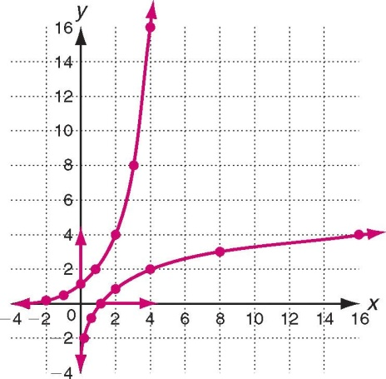
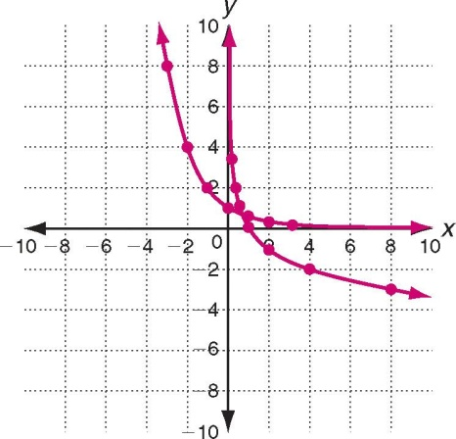

Practice C)
1. log₂₀ 8000 = 3 2. log₁₁ 14,641 = 4 3.log_{a} c = b 4. 10⁷ = 10,000,000
5. 6³ = 216 6. p^{r} = q 7. 0 8. 4
9. 3 10. 5 11. 0 12. 4
13. Domain: {x|x > 0}; range: all real numbers 14. Domain: {x|x > 0}; range: all real numbers
