**Algebra 2 Honors Name**

**WS: Summer Work Extra Practice Date Block**

**In 1 – 2, write the slope-intercept form of the equation of the line through the given points.**

1.  2. 

**In 3 – 4, solve each system by graphing.**

1. 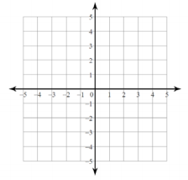 4. 

**In 5 – 7, solve each system using substitution or elimination.**

1.  6.  7. 

**In 8 – 12, simplify completely. Your answer should contain only positive exponents.**

1.  9.  10. 

11.  12. 

**In 13 – 14, find the product of each expression.**

1.  14. 

**In 15 – 18, factor completely.**

1.  16. 
2.  18. 

**In 19 – 20, solve by factoring.**

1.  20. 